Community Day Charter Public School
7th Grade Summer Reading List
Your Goal: To read a minimum of 3 books from the following list.
What you will have to do in Aug/Sept 2017:
- Take a short comprehension quiz on one book.
- Complete your first project on the second book.
- Write your first book review on the third book.

1. Listen, Slowly by Thanhha Lai | 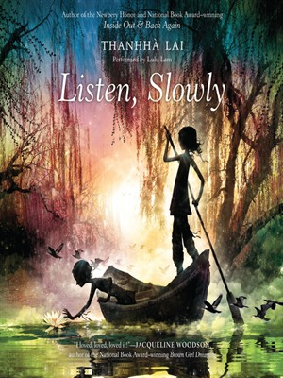 | 5. Popular by Maya Van Wagenen | 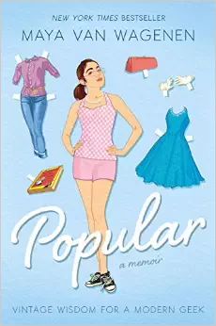
2. Loot by Jude Watson | 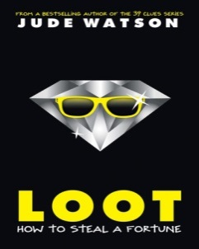 | 6. Greenglass House by Kate Milford
3. Marina by Carlos Ruiz Zafon | 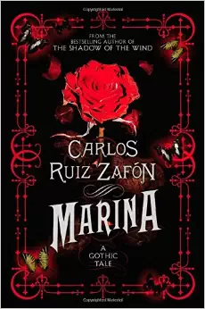 | 7. Echo by Pam Munoz Ryan | 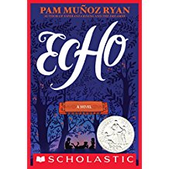
4. As Brave As You by Jason Reynolds | 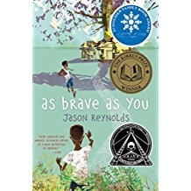 | 8. The Girl Who Drank the Moon by Kelly Barnhill | 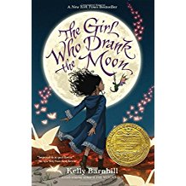
9. The Riverman: by Aaron Starmer | 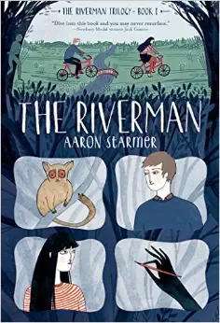 | 14. The Boundless by Kenneth Oppel | 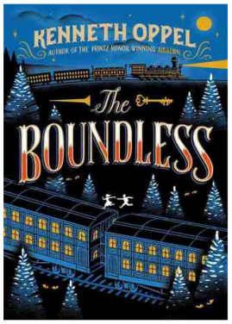
10. The Night Gardener by Jonathan Auxier | 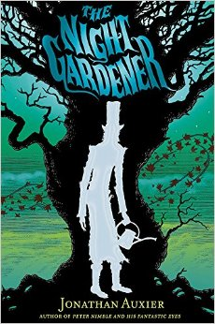 | 15. Threatened by Eliot Schrefer | 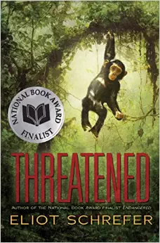
11. The Crossover by Kwame Alexander | 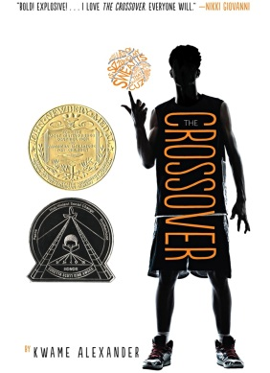 | 16. The Port Chicago 50 by Steve Sheinkin | 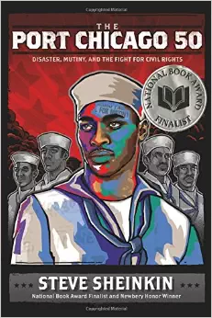
12. The Dumbest Idea Ever by Jimmy Gownly |  | 17. A Time to Dance by Padma Venkatraman | 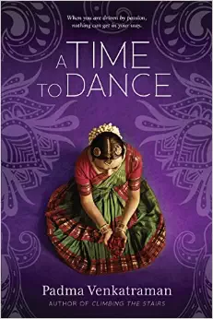
13. Pax by Sara Pennypacker | 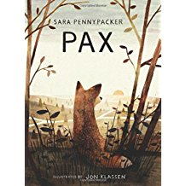 | 18. Woof by Spencer Quinn | 