Name: __________________________________________ Date: __________________________

The First American Woman Doctor

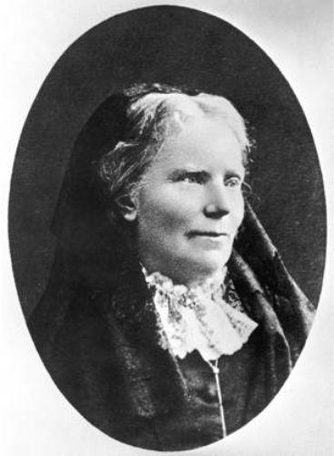

Elizabeth Blackwell was the first woman to become a medical doctor in the United States. Elizabeth was born in England more than a hundred years ago. She moved to the U.S. when she was about eleven years old.
At first, Elizabeth was a teacher. Later, she knew she wanted to study medicine.
Elizabeth applied to many medical schools in the United States, but they would not take her. These schools were only allowing men to study medicine. Finally, Elizabeth found a school that let her in. Some men at the school did not want a woman there, however. At first, they were not kind to her.
After two years, Elizabeth graduated at the top of her class at the medical school. She and her sister opened a clinic for women and children in New York City. They gave medical care to the poor. Dr. Blackwell also opened a medical college for women. She trained women to become doctors. She also gave speeches and wrote books.
Dr. Elizabeth Blackwell had courage and strong character. She worked hard for the things she wanted to do. Her work encouraged other women to become doctors.
© 2014 ReadWorks®, Inc. All rights reserved.

Directions: Use text evidence to answer the following questions about Elizabeth Blackwell. For each question, go back to the text and mark where you found your evidence!

- Who was Elizabeth Blackwell?

  - The first woman to become a medical doctor in the United States
  - The first woman to become a medical doctor in England
  - The first person to become a medical doctor in the United States

- The article describes a big problem that Elizabeth Blackwell had to deal with. What was this problem?

  - People did not take Elizabeth seriously after she became a doctor.
  - Many medical schools and men did not want women to study medicine.
  - Elizabeth’s family did not have enough money to send her to medical school.

- What did Elizabeth Blackwell do before she decided to study medicine?

  - She opened a medical college for women.
  - She was a teacher.
  - She applied to medical school.

- Read these sentences from the text.

“After two years, Elizabeth graduated top of her class at the medical school. She and her sister opened a clinic for women and children in New York City. They gave medical care to the poor. Dr. Blackwell also opened a medical college for women. She trained women to become doctors. She also gave speeches.”

What conclusion can you draw from this evidence?

  - Dr. Blackwell did the same things that male doctors did after finishing school.
  - Dr. Blackwell was a very successful student and doctor.
  - Dr. Blackwell had trouble being a doctor after finishing medical school.

- What is the main idea of this article?

  - Elizabeth Blackwell worked hard through medical school and graduated at the top of her class.
  - Elizabeth Blackwell did not want to be a teacher anymore, so she became a doctor instead.
  - Elizabeth Blackwell worked hard to become the first American woman doctor, and she was very successful.

- Elizabeth Blackwell was a courageous person. What evidence from the text supports this statement?
________________________________________________________________________________________________________________________________________________________________________________________________________________________________________________________________________________________________________________________________________________________________________________________________________________________________________________________________________________________________________________________________________________________________________________________________________________________________________________________________________________________________________________________________________________________________________________________________________________________________________________________________________

- What other character trait best describes Elizabeth Blackwell? Use evidence from the text to support your answer.

_____________________________________________________________________________________________________________________________________________________________________________________________________________________________________________________________________________________________________________________________________________________________________________________________________________________________________________________________________________________________________________________________________________
_________________________________________________________________________________________________________
_________________________________________________________________________________________________________
_________________________________________________________________________________________________________

Name: __________________________________________ Date: __________________________

Stuck in the Icy Ocean
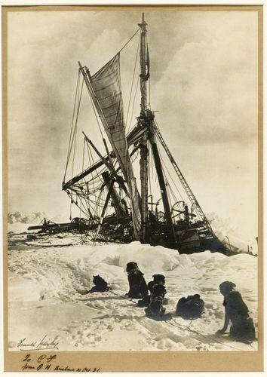
Ernest Shackleton was an explorer. In 1914, he led an expedition to Antarctica. Things went wrong, however. As Shackleton and twenty-seven men sailed toward the South Pole, their ship became stuck in ice.
The ice would not melt until spring. Shackleton wondered whether he and his shipmates should spend the freezing winter months on the ship. They knew the ice had damaged their ship and that it would sink in the spring.
Shackleton finally decided that he and his men had to leave the ship. They ended up camping on a sheet of ice. They watched their ship sink, safe for the moment. But Shackleton knew they were still in danger. Soon, the sheet of ice they were living on started to melt. Shackleton ordered his men onto the small lifeboats the big ship carried. They all sailed to a nearby island. The men could not find shelter or life there. They could not stay.
Shackleton met his new problem with courage. He and five men sailed in a small lifeboat to another island. They found people there. Shackleton sent a ship to bring back the twenty-two other men. The rescue was successful! After two years at sea, every crewman had been saved.
Ernest Shackleton solved the problems his men faced. He took a dangerous trip to save his crew. Today, many people consider him a hero.
© 2014 ReadWorks®, Inc. All rights reserved.

Directions: Use text evidence to answer the following questions about Ernest Shackleton. For each question, go back to the text and mark where you found your evidence!
- To where did Ernest Shackleton and his men sail?

  - Antarctica
  - North America
  - Europe

- What main problem did Shackleton and his crew face?

  - They ran out of food and supplies.
  - They weren’t good at steering the ship.
  - Their ship got stuck in the ice.

- Read the following sentence.
“Ernest Shackleton solved the problems his men faced.”

Which piece of evidence from the article supports this statement?

  - “Soon, the sheet of ice they were living on started to melt. Shackleton ordered his men onto the small lifeboats the big ship carried.”
  - “Ernest Shackleton was an explorer. One hundred years ago, he led an expedition to Antarctica.”
  - “As Shackleton and twenty-seven men sailed toward the South Pole, their ship became stuck in ice.”

- What is the main idea of this article?

  - Shackleton was a talented explorer, but his crew saved his life during their journey to Antarctica.
  - Shackleton faced many dangers during his expedition but was able to save his entire crew.
  - Shackleton and his crew sailed to Antarctica without facing any major problems.

- Read this paragraph from the article.

“They ended up camping on a sheet of ice. They watched their ship sink, safe for the moment. But Shackleton knew they were still in danger. Soon, the sheet of ice they were living on started to melt.”

Based on these sentences, what does the word danger mean?

- a cold and wet area
- an unsafe situation
- a safe place

- How did Ernest Shackleton show courage during his Antarctic expedition? Support your answer using evidence from the text.

________________________________________________________________________________________________________________________________________________________________________________________________________________________________________________________________________________________________________________________________________________________________________________________________________________________________________________________________________________________________________________________________________________________________________________________________________________________________________________________________________________________________________________________________________________________________________________________________________________________________________________________________________
- Many people think of Ernest Shackleton as a hero. What character traits are important in a hero? Support your answer using evidence from the text.

_____________________________________________________________________________________________________________________________________________________________________________________________________________________________________________________________________________________________________________________________________________________________________________________________________________________________________________________________________________________________________________________________________________
__________________________________________________________________________________________________________________________________________________________________________________________________________________

Name: __________________________________________ Date: __________________________

Meet Rosa Parks
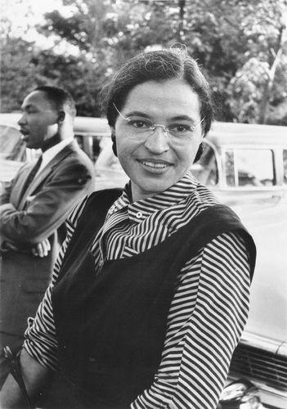
Years ago, places in the United States had laws that kept black people and white people apart. In some cities, laws said that black people could not sit next to white people on buses. Other laws did not allow black people to use the same drinking fountains or restrooms as white people.
One day, an African American woman named Rosa Parks got on a bus. After she sat down, the bus became full. The bus driver told Rosa to give up her seat to a white man. Rosa refused. She believed it was not fair that she had to give up her seat.
Rosa was arrested after refusing to move. People heard about Rosa’s protest against the law. Some people said there should be fairer laws. Soon, more people began demanding that the law be changed.
Slowly, places in the United States began changing their laws. Bus drivers were no longer allowed to make black people give up their seats. New laws said black people must be able to use the same drinking fountains and restrooms as white people.
Rosa Parks spoke out for what she believed in. She was a person of strong character. We remember Rosa today as a hero who worked for fairness and equality.
© 2014 ReadWorks®, Inc. All rights reserved.

Directions: Use text evidence to answer the following questions about Rosa Parks. For each question, go back to the text and mark where you found your evidence!

- What did Rosa Parks refuse to do on a bus?
  - Sit down instead of standing up
  - Give up her seat to a white man
  - Give up her seat to an old lady

- Rosa’s protest caused some people to start saying the law should be changed. What happened as a result of people demanding change?

  - Places in the United States slowly began changing their laws.
  - Rosa was arrested for refusing to change seats on the bus.
  - Rosa started to believe that the laws were not fair.

- Read these sentences from the text.
“Rosa Parks spoke out for what she believed in. She was a person of strong character.”

What evidence from the text supports this statement?
  - Rosa refused to give up her seat on the bus because she thought it was unfair.
  - Some people who heard about Rosa’s protest started saying there should be fairer laws.
  - When the bus Rosa was on became full, the bus driver told her to give up her seat.

- What is the main idea of this article?

  - Rosa Parks wanted to be able to sit down on a bus, but the law stopped her from sitting.
  - The United States used to have many laws that kept black and white people apart.
  - Rosa Parks spoke out against a law she thought was unfair which helped change other laws in the United States.

- Read these sentences from the text.

“The bus driver told Rosa to give up her seat to a white man. Rosa refused. She believed it was not fair that she had to give up her seat.”

“Rosa was arrested after refusing to move.”

Based on these sentences, what does the word “refuse” mean?
- say no
- yell
- cry

6. What character trait best describes Rosa Parks? Use evidence from the text to support your answer.

_______________________________________________________________________________________________________________________________________________________________________________________________________________________________________________________________________________________________________________________________________________________________________________________________________________________________________________________________________________________________________________________________________________________________________________________________________________________________________________________________________________________________________________________________________________________________

