An American Leader

Martin Luther King Jr. was a leader who dreamed of a better world. Martin Luther King Jr. was born on January 15, 1929, in Atlanta, Georgia. Each January, Americans honor him with a holiday. Martin Luther King Jr. Day is celebrated on the third Monday in January.

When King was growing up, the laws in some places were unfair. Those laws treated African American people differently from white people. African Americans were not allowed to go to the same schools as white students. Many were also forced to sit in the back of buses.

In the 1950s and 1960s, King worked to change unfair laws. He led peaceful marches and gave many speeches. In 1963, King gave his famous "I Have a Dream" speech. He said, "I have a dream that my four little children will one day live in a nation where they will not be judged by the color of their skin but by the content of their character."

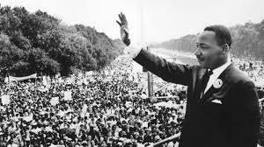
King gives "I Have a Dream" speech to a large crowd in Washington, D.C.

1. During which month do Americans celebrate Martin Luther King Jr. Day?

A. January

B. February

C. March

2. Martin Luther King Jr.'s work to change unfair laws was caused by a desire for people to be treated fairly. What was an effect of King's work?

A. Martin Luther King Jr. led marches and gave speeches.

B. Equal rights laws were passed, so Americans are treated fairly.

C. African Americans and whites went to separate schools.

3. African Americans were treated unfairly. What evidence from the passage best supports this conclusion?

A. African Americans were forced to sit in the back of buses.

B. Martin Luther King Jr. led marches and gave speeches.

C. Americans honor Martin Luther King Jr. with a holiday.

4. Read the following sentence from King's speech:

"I have a dream that my four little children will one day live in a nation where they will not be judged by the color of their skin but by the content of their character."

How did Martin Luther King Jr. feel about the future of America?

A. scared

B. angry

C. hopeful

5. What is this passage mostly about?

A. Martin Luther King Jr.'s "I Have a Dream" speech

B. Why African Americans were treated differently than white people

C. How Martin Luther King Jr. helped change unfair laws.

6. Why do Americans celebrate Martin Luther King Jr. Day?

__________________________________________________________________________________________
________________________________________________________________________________________________________________________________________________________________________________________________________________________________________________________________________________________________________________________________________________________________________

Patricia Bath

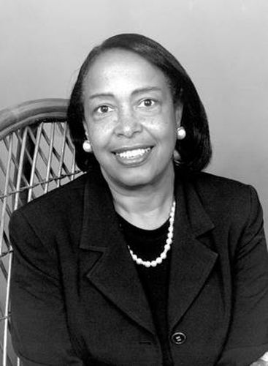
Vision is one of your five senses. It is an important way you take in information about the world around you. But as people get older, they can sometimes start to lose their eyesight. One thing that can cause this is a cataract. A cataract is when part of a person’s eye that is supposed to be clear gets cloudy. This makes it harder for the person to see well.

One important inventor created a tool that helps get rid of people’s cataracts. Her name is Patricia Bath. Patricia is an eye doctor. She has spent a lot of time studying eyesight in different people. As a doctor, she found that some people were more likely than others to have eye problems. For example, she found that African Americans were more likely to become blind than other patients. Patricia thought it was important to help treat people’s eye problems. She thought everyone had a right to sight.

In the 1980s, she invented the tool that helps get rid of people’s cataracts. It used a laser. Before her invention, getting rid of a cataract was tough. It did not always have good end results. And it could be painful for the patient. But Patricia’s tool was better. It was more accurate because of the laser. And it was more comfortable for the patient!

Thanks to Patricia’s invention, many people have gotten their eyesight back!

1. What does a cataract make hard for a person to do?

A. smell well

B. hear well

C. see well

2. What does the text describe?

A. Patricia Bath's experience as a doctor

B. Patricia Bath's invention that helps get rid of cataracts

C. The causes of different kinds of eye problems

3. Based on the text, who is most likely to have cataracts?

A. a baby

B. a teenager

C. an elderly person

4. Read the following sentences:

"In the 1980s, she invented the tool that helps get rid of people's cataracts. It used a laser. Before her invention, getting rid of a cataract was tough. It did not always have good end results. And it could be painful for the patient. But Patricia's tool was better. It was more accurate because of the laser. And it was more comfortable for the patient!"

Based on this information, why was Patricia Bath's invention to get rid of cataracts better than what people had been using to get rid of cataracts?

A. It was better at getting rid of cataracts and it was less painful for the patient.

B. It was faster at getting rid of cataracts.

C. It was less painful for the patient and took less time to remove cataracts.

6. What is the main idea of the text?

A. Patricia is an eye doctor who invented a better tool to remove cataracts and improve people's eyesight.

B. A cataract is when part of a person's eye that is supposed to be clear gets cloudy.

C. Tools with lasers that are used to remove cataracts are more accurate than those that don't have lasers.

Henry Ossawa Tanner
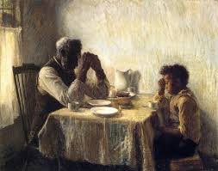
The painting shown here is called The Thankful Poor. The painting shows a grandfather and his grandson giving thanks before eating their food. What do you notice about the way the grandfather and his grandson are painted? What do you notice about other details shown in the painting? Why might the painting have been titled The Thankful Poor?
This painting was made by Henry Ossawa Tanner in 1894. Henry was the first African American painter who became known around the world for his art. He often painted religious paintings. He painted scenes from the Bible. The Bible is the main holy book of the Christian and Jewish religions.
The Thankful Poor
Henry's artistic work was influenced by his childhood. He grew up in a religious home. His father was a minister. Henry was raised in Philadelphia, Pennsylvania. In the United States, he faced racism. As an adult, Henry moved to Paris, France with the hope of escaping this racism. He wanted to be judged for his art, not his skin color. Soon after moving to Paris, Henry achieved success. People around the world began to admire him for his work.

1. Who was Henry Ossawa Tanner?
A. He was the first African American painter who became known around the world for his art.
B. He was the first African American painter who painted religious paintings.
C. He was the first African American painter who moved to Paris, France.

2. The text describes Henry Ossawa Tanner's paintings. How does the text describe these paintings?
A. His paintings often showed family members spending time together in their homes.
B. His paintings often showed nature and scenes of the places he visited in Paris, France.
C. The paintings he created were often religious paintings that showed scenes from the Bible.

4. Based on the text, what can you conclude about Henry Ossawa Tanner's time in the United States as a painter?
A. People sometimes judged him based on the color of his skin, and not based on his art.
B. People mostly judged him based on his paintings, and not on the color of his skin.
C. People always treated him fairly and with kindness, no matter where he went.
5. What is the main idea of this text?
A. As an adult, Henry Ossawa Tanner moved to Paris, France with the hope of escaping racism and finally being judged for his art, not his skin color.
B. The Thankful Poor is a painting by Henry Ossawa Tanner that shows a grandfather and his grandson giving thanks before eating their food.
C. Henry Ossawa Tanner was an African American painter who often created religious paintings, and moved to Paris to escape the racism he faced in the United States.

6. What character trait best describes Henry Ossawa Tanner? Use evidence from the text to support your answer.
__________________________________________________________________________________________
__________________________________________________________________________________________
__________________________________________________________________________________________________________________________________________________________________________________________________________________________________________________________________________________________________________________________________________________________________________________________________________________________________________________________________

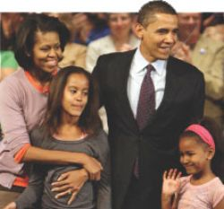
Barack Obama

The president of the United States has an important job. He or she is the leader of the armed forces. This person executes and enforces United States laws. The president is able to sign bills to become laws. He or she is also able to veto, or reject, laws. In addition, the president works with the leaders of other countries.
Meet Barack Obama! He was the 44th president of the United States. He was the first African American to become a U.S. president. Obama was elected in November 2008. In January 2009, he began a four-year term as president. In November 2012, Obama was reelected for a second term.
Barack Obama and his wife, Michelle, have two daughters. Their names are Malia and Sasha. They all lived in the White House during his presidency. It has been home to every president except George Washington.
The White House has 132 rooms and 35 bathrooms! One room is called the Oval Office. That is where the president usually works. In another room called the Cabinet Room, the president meets with people like the heads of the U.S. government departments, members of Congress, and leaders of foreign nations. Here they talk about topics such as national security and energy. The discussions are often about how to help solve national and global problems.

1. Who was the 44th president of the United States?
A. Barack Obama
B. Michelle Obama
C. George Washington

2. What does the author describe at the beginning of the text?
A. Barack Obama and his family
B. the job of the president of the United States
C. some rooms in the White House

3. The White House is a big building. What evidence from the text supports this conclusion?
A. The president and the president's family live in the White House.
B. The Oval Office is in the White House.
C. The White House has 132 rooms.

4. Read this sentence from the text.
"In November 2012, Obama was reelected for a second term."

Based on this information, what conclusion can you make?
A. Many Americans wanted Obama to be president again.
B. Obama did not want to be president again.
C. Obama did not do a good job during his first term as president.

5. Who is this passage mostly about?
A. Barack Obama
B. Michelle Obama
C. George Washington

6. Read the following sentences.
"Obama was elected in November 2008. In January 2009, he began a four-year term as president. In November 2012, Obama was reelected for a second term."

What does the word "reelected" mean?
A. chosen again
B. kicked out
C. moved away

7. Based on the text, name three things that are the U.S. president's job.
__________________________________________________________________________________________
__________________________________________________________________________________________
______________________________________________________________________________________________________________________________________________________________________________________________________________________________________________________________________________

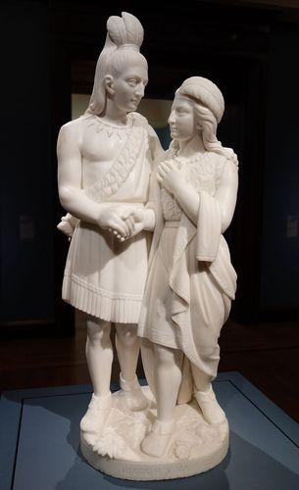
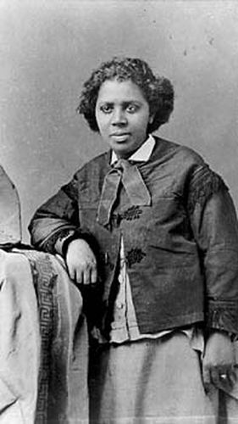
Edmonia Lewis

Edmonia Lewis was the first professional African American sculptor. She made sculptures of abolitionists, presidents, and figures inspired by poetry and her background. An abolitionist is someone who supported the end of slavery before the Civil War.
Edmonia was born in New York. Her father was African American. Her mother was Native American. She moved to Boston when she was about 19 years old. She started to learn how to make sculptures while she was there. She started to make sculptures of abolitionists like John Brown.
A few years later, Edmonia traveled to Europe. She decided to live in Rome, Italy for a while. She continued to make sculptures there. Unlike most sculptors working in Rome at the time, Edmonia made her sculptures without help from others. She created sculptures of presidents Abraham Lincoln and Ulysses S. Grant. She made a sculpture inspired by her Native American background. This sculpture showed a father teaching his daughter how to make an arrow.
Many of Edmonia Lewis's sculptures have been lost. The ones that have survived show how talented Edmonia really was.

1. Who was Edmonia Lewis?
A. the first professional African American painter
B. the first professional African American photographer
C. the first professional African American sculptor

2. The text describes a sequence of some important events in Edmonia Lewis's life. What happened in her life before she decided to travel to Europe?
A. She moved back to America after living in Rome, Italy.
B. She moved to Boston and learned how to make sculptures.
C. She stopped making sculptures of presidents.

3. Based on the text, what inspired some of the sculptures Edmonia Lewis made?
A. people she may have admired and appreciated
B. the beauty of the European places she visited
C. her childhood dreams

4. Read the following sentences from the text:
"She decided to live in Rome, Italy for a while. She continued to make sculptures there. Unlike most sculptors working in Rome at the time, Edmonia made her sculptures without help from others. "

What does this information tell us about how hard Edmonia Lewis worked?
A. Edmonia Lewis did not work very hard to make her sculptures.
B. Edmonia Lewis only worked hard to make her sculptures when she was not busy.
C. Edmonia Lewis worked very hard to make her sculptures.

5. What is an abolitionist?

An abolitionist is someone who supported the end of slavery before the Civil War.

An abolitionist is someone who makes sculptures out of clay for decoration.
- An abolitionist is someone who is inspired by their Native American background.

6. What is the main idea of this text?
A. Edmonia Lewis traveled to Europe and decided to live in Rome, Itay. While she lived in Rome, Edmonia Lewis made her sculptures without help from others.
B. Edmonia Lewis was born in New York, and she moved to Boston when she was 19 years old. There she learned how to make sculptures.
C. Edmonia Lewis, the first professional African American sculptor, made sculptures of abolitionists, presidents, and figures inspired by her background.

Bonus! Using what you have at home, make a sculpture of someone who is important to you!

