Summer Reading
CDCPS 2019
Grade 5

This summer you will be required to read 1 book:

Wishtree
By Katherine Applegate
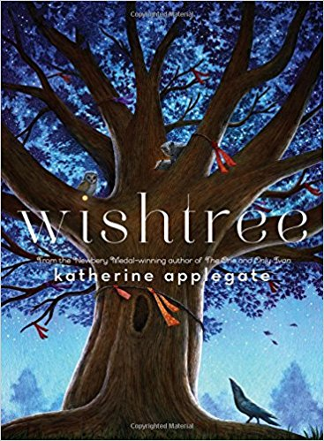

As you read, there will be short check-in questions to complete. These check-in questions will be used to check your understanding. If you answer them correctly, keep going! If not, you should make sure to re-read.

Summer Reading
The Stars Beneath Our Feet by David Barclay Moore | 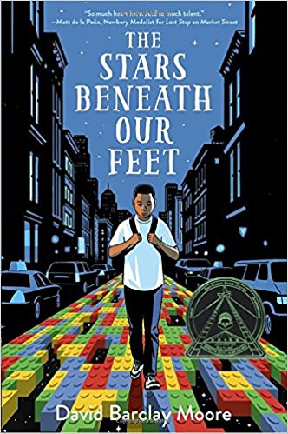 | Echo by Pam Munoz Ryan | 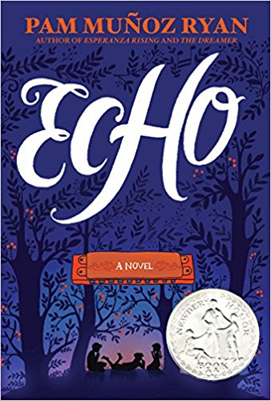
Hello Universe by Erin Entrada Kelly | 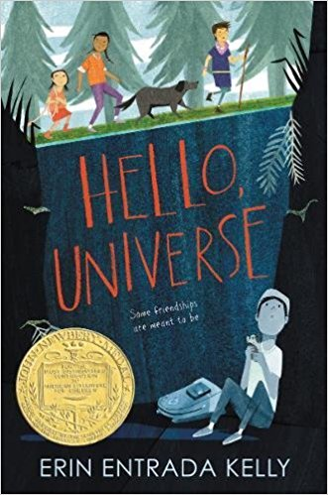 | Woof by Spencer Quinn | 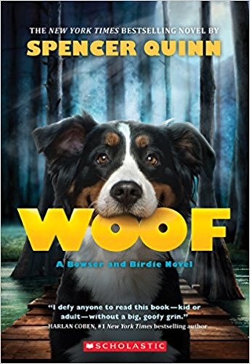
Lucky Broken Girl by Ruth Behar | 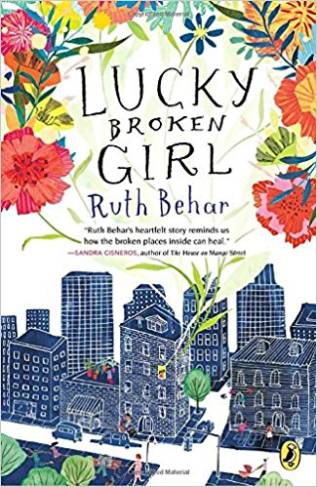 | The Murderer’s Ape by Jakob Wegelius | 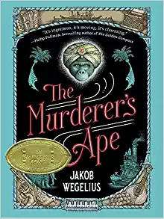
Sweep: The Story of a Girl and her Monster by Jonathan Auxier | 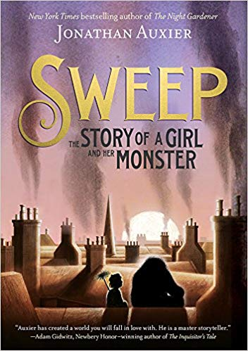 | The Bridge Home by Padma Venkatraman | 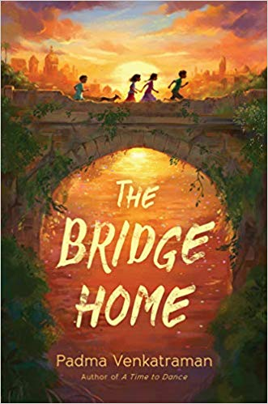
Dactyl Hill Squad by Daniel Jose Older | 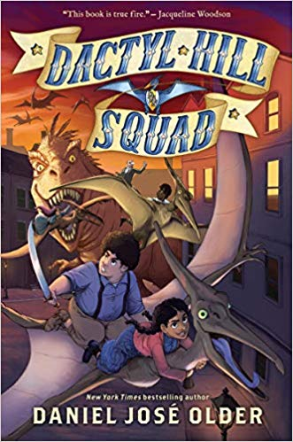 | The Book of Boy by Catherine Gilbert Murdock | 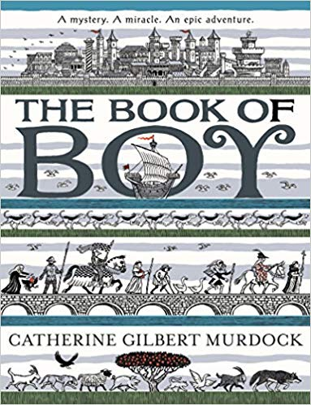
Merci Suarez Changes Gears by Meg Medina | 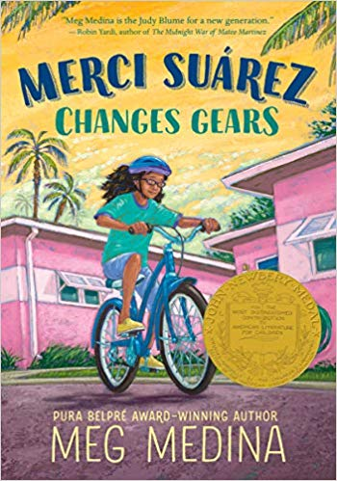 | Chasing Space (Young Readers’ Edition) by Leland Melvin
Spooked! By Gail Jarrow | 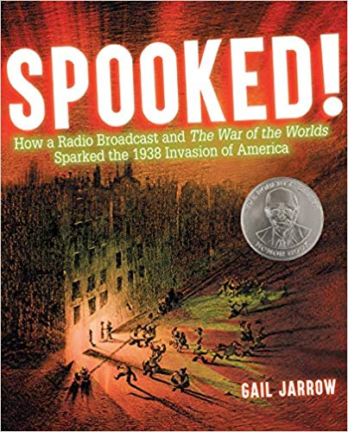 | The Girl Who Drew Butterfiles by Joyce Sidman | 