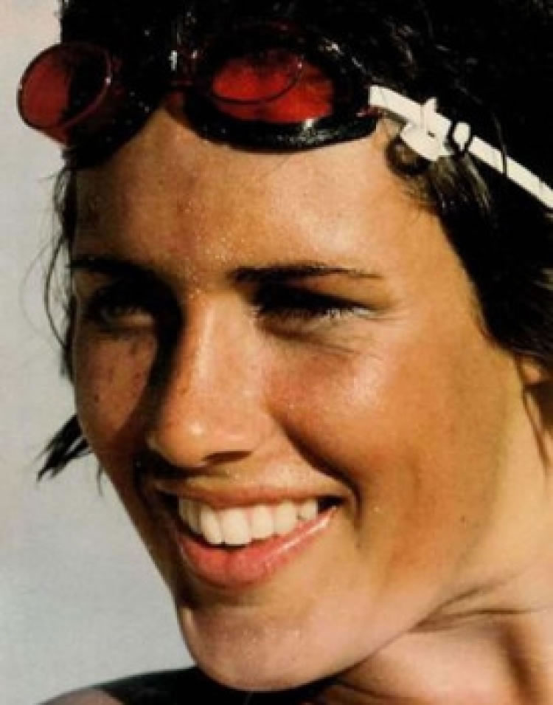
Diana Nyad
Diana Nyad was born in New York City on August 22, 1949. Her family moved to Florida when Diana was a child. While there, she joined her school’s swim team. Diana had an unstable childhood, and she used swimming as a safe place.

Diana continued to swim in college, and she graduated from Lake Forest College. She began to train for marathon swimming and soon set world speed records. In 1975 she swam the 28 miles around Manhattan in less than 8 hours. A few years later, she set a distance record by swimming 102 miles from the Bahamas to Florida.

For the next several decades, Diana stopped swimming and became a sports journalist. She wrote articles and appeared on T.V. shows. After her mother passed away in 2007, Diana got back into the water. In 2011 Diana began trying to swim from Cuba to Florida, a distance of 110 miles. On her fifth try, she finally completed the dangerous journey in 2013. She swam for 53 hours, going without sleep. She had a nurturing team of 35 people who helped her eat, kept her on course, and gave her medical attention.

On September 10, 2013, Nyad appeared on The Ellen DeGeneres Show. She explained that she started her training in the Caribbean in January 2013 with 12-hour workouts of nonstop swimming. Nyad also said that while she swims she remembers books, sings, counts numbers and thinks about The Wizard of Oz.

Diana Nyad has become a shining example to athletes around the world!
Directions: Use text evidence to answer the following questions about Diana Nyad. For each question, go back to the text and mark where you found your evidence!

1. Who was Diana Nyad?
  - The first woman to swim in the Atlantic Ocean.
  - The first person to swim 110 miles without stopping.
  - The first person to go 53 hours without sleep.

2. Which event happened first in Diana Nyad’s life?
  - Diana set the record for swimming 102 miles
  - Diana became a sports journalist
  - Diana moved to Florida.

3. It took Diana _____ tries to swim from Cuba to Florida.
  - 5
  - 7
  - 2

4. Ms. Borglund thinks that Diana Nyad is determined. Which evidence supports that claim?
  - “Diana Nyad was born in New York City on August 22, 1949.”
  - “She swam for 53 hours, going without sleep.”
  - “On September 10, 2013, Nyad appeared on The Ellen DeGeneres Show.”

5. This passage is mostly about the accomplishments in Diana Nyad’s life. Which piece of evidence supports this claim?
  - “Nyad also said that while she swims she remembers books, sings, counts numbers and thinks about The Wizard of Oz.”
  - “She set a distance record by swimming 102 miles from the Bahamas to Florida.”
  - “Her family moved to Florida when Diana was a child.”

Read the following sentence.

She had a nurturing team of 35 people who helped her eat, kept her on course, and gave her medical attention.

6. According to the clues in the sentence, what does the word, nurturing, mean?
a. Helpful
b. Large
c. Teamwork

7. Why does the author say, “Diana Nyad has become a shining example to athletes around the world”?

____________________________________________________________________________________________________________________________________________________________________________________________________________________________________________________________________________________________________________________________________________________________________________________________________________________________________________________________________________________________________________________________________________

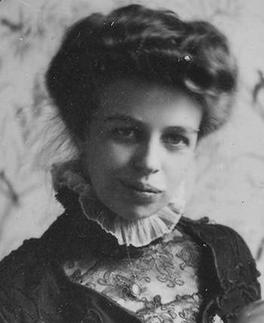
Eleanor Roosevelt
Eleanor Roosevelt was born on October 11, 1884 in New York City. She was a shy child who experienced great loss at a young age. Her mother died when she was eight years old, and her father died just two years later.

In 1905, Eleanor married Franklin D. Roosevelt, who would later become President of the United States. The couple had six children together. After her husband got polio, she began helping him with his political career.

When he became president in 1933, Eleanor changed the role of the First Lady. Instead of staying quietly in the background, she gave press conferences on human rights, children’s causes, and women’s rights. She believed in justice for all. She worked for the League of Women Voters and even wrote her own newspaper article called “My Day.”

After her husband passed away in 1945, Eleanor began working for the United Nations and fought for rights for every person. She fought most of her life for justice and equality for all. Eleanor Roosevelt is thought of as a great leader who spoke out for those who didn’t have a voice.
Directions: Use text evidence to answer the following questions about Eleanor Roosevelt. For each question, go back to the text and mark where you found your evidence!

1. Who was Eleanor Roosevelt?
  - The First Lady who spoke out for human rights.
  - The first woman president.
  - She spoke up against the rights of children.

2. What happened right after Eleanor Rosevelt’s husband passed away?
a. Eleanor became the First Lady.
b. Eleanor began working for the United Nations.
c. Eleanor wrote her own newspaper article called “My Day.”

4. Ms. Sinclair thinks that Eleanor Roosevelt is caring. Which evidence supports that claim?
  - “She was a shy child who experienced great loss at a young age.”
  - “When he became president in 1933, Eleanor changed the role of the First Lady.”
  - “She fought most of her life for justice and equality for all.”

Read the following sentence.

“She gave press conferences on human rights, children’s causes, and women’s rights. She believed in justice for all.

5. According to the clues in the sentence, what does the word, justice, mean?
a. Food for all people
b. Rights of all people
c. Judging others in court

6. The author states that, “Eleanor Roosevelt is thought of as a great leader who spoke out for those who didn’t have a voice.” How is that similar to what we studied about with Malala?

_____________________________________________________________________________________________________________________________________________________________________________________________________________________________________________________________________________________________________________________________________________________________________________________________________________________________________________________________________________________________________________________________________________
_________________________________________________________________________________________________________
_________________________________________________________________________________________________________

7. What other character trait best describes Eleanor Roosevelt? Use evidence from the text to support your answer.

_________________________________________________________________________________________________________
_________________________________________________________________________________________________________
__________________________________________________________________________________________________________________________________________________________________________________________________________________
_________________________________________________________________________________________________________
_________________________________________________________________________________________________________

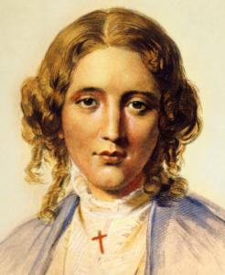
Harriet Beecher Stowe
Harriet Beecher was born on June 14, 1811 in Litchfield, Connecticut. She was one of 13 children born to her parents, Lyman and Roxanna. Her family was well-educated and strongly believed in the rights and equality for all people. Her father was the head of a church seminary and spoke openly about his views against slavery. Harriet grew up also believing that slavery was wrong.

After marrying Calvin Stowe in 1836, the couple moved to Brunswick, Maine. When Congress passed the Fugitive Slave Law, which stated that southern slaveholders could find and capture slaves who had escaped slavery, Harriet knew she had to tell the world about her feelings on slavery. In 1852, her book called Uncle Tom’s Cabin was published. It talked about how slavery felt for the families and children in slavery. The book became very popular and sold more than 300,000 copies in three months. This book helped to shape the country’s thoughts on slavery. After meeting with Abraham Lincoln, it is said that he told her, “So you are the little woman who wrote the book that started this great war.”

Harriet continued to write for the rest of her life. She also continued to fight for equality for women and African Americans. She believed that everyone deserved to be treated fairly. She is still thought to be one of the champions in the fight for equality.
Directions: Use text evidence to answer the following questions about Harriet Beecher Stowe. For each question, go back to the text and mark where you found your evidence!

- What was Harriet Beecher Stowe most known for?
  - She helped educate the poor.
  - She wrote a book based on the experience of slaves.
  - She met with Abraham Lincoln.

- According to the text, well educated means ______________________________________________ ________________________________________________________________________________________________.

- What happened right before Congress passed the Fugitive Slave Law?
  - Harriet met Abraham Lincoln.
  - Harriet wrote Uncle Tom’s Cabin.
  - Harriet and her husband moved to Maine.

- Why is Harriet Beecher Stowe famous or well-known?
_________________________________________________________________________________________________________
_________________________________________________________________________________________________________
__________________________________________________________________________________________________________________________________________________________________________________________________________________
_________________________________________________________________________________________________________
_________________________________________________________________________________________________________

- How is Harriet Beecher Stowe similar to the historical heroes we have studied in class?
_________________________________________________________________________________________________________
_________________________________________________________________________________________________________
__________________________________________________________________________________________________________________________________________________________________________________________________________________
_________________________________________________________________________________________________________
_________________________________________________________________________________________________________

- How is Harriet Beecher Stowe different than the historical heroes we have studied in class?
_________________________________________________________________________________________________________
_________________________________________________________________________________________________________
__________________________________________________________________________________________________________________________________________________________________________________________________________________
_________________________________________________________________________________________________________
_________________________________________________________________________________________________________

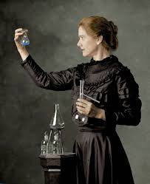
Marie Curie
Marie Curie was born as Maria Sklodowska in Warsaw, Poland on November 7, 1867. Marie was a bright student who loved chemistry and physics. Marie couldn’t attend the men-only University of Warsaw, so she worked for five years saving money until she could afford to go to Paris and attend Sorbonne University. She had so little money that she would only eat buttered bread and tea. Her poor diet would sometimes affect her health.

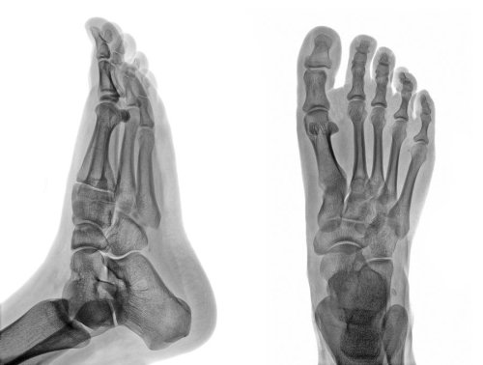
Marie earned her master’s degree in Physics in 1893. After needing a lab to work in, she met French physicist Pierre Curie. The pair fell in love and married on July 26, 1895. They began working together after Marie discovered and named radioactivity, after she studied the element uranium. While working together they discovered two new elements: polonium (named after Marie’s home country of Poland), and radium. Marie won her first Nobel Prize in 1903. In 1911 she won her second Nobel Peace Prize.

Marie continued to work in the science field. She
encouraged people to use a portable X-ray machine during World War I by speaking to doctors about how the machine can help hurt soldiers. She is still considered to be one of the best scientists in our history.
Fun Fact!

When a doctor needs to see something inside of your body, they might use an X-ray machine to take pictures of the inside of you from the outside of you. The picture of your body is pretty cool, too. Solid things like your bones will show up white while squishy materials like your muscles will look gray. The air in your lungs will look black!

Directions: Use text evidence to answer the following questions about Marie Curie. For each question, go back to the text and mark where you found your evidence!

- Marie Curie was most known for …
  - earning a Master’s Degree.
  - discovering polonium and radium.
  - Attending the University of Warsaw.

- Which year did Marie Curie win her second Nobel Peace Prize?
  - 1867
  - 1911
  - 1895

3. Why did Marie Curie only eat buttered bread and tea in her early life?
  - It was her favorite meal.
  - She was allergic to other foods.`
  - It was all she could afford.

4. Marie Curie won ______ Nobel Prizes.
- One
- Five
- Two

Read the following sentence.

“She encouraged people to use a portable X-ray machine during World War I by speaking to doctors about how the machine can help hurt soldiers.”

5. According to the clues in the sentence, what does the word, encouraged, mean?
  - Convinced
  - Yelled
  - Screamed

6. What is the purpose of an x-ray machine? Why would Marie Curie encourage doctors to use it during World War 1?

_________________________________________________________________________________________________________
_________________________________________________________________________________________________________
__________________________________________________________________________________________________________________________________________________________________________________________________________________
_________________________________________________________________________________________________________
_________________________________________________________________________________________________________

7. What character trait best describes Marie Curie? Use evidence from the text to support your answer.

_________________________________________________________________________________________________________
_________________________________________________________________________________________________________
__________________________________________________________________________________________________________________________________________________________________________________________________________________
_________________________________________________________________________________________________________
_________________________________________________________________________________________________________

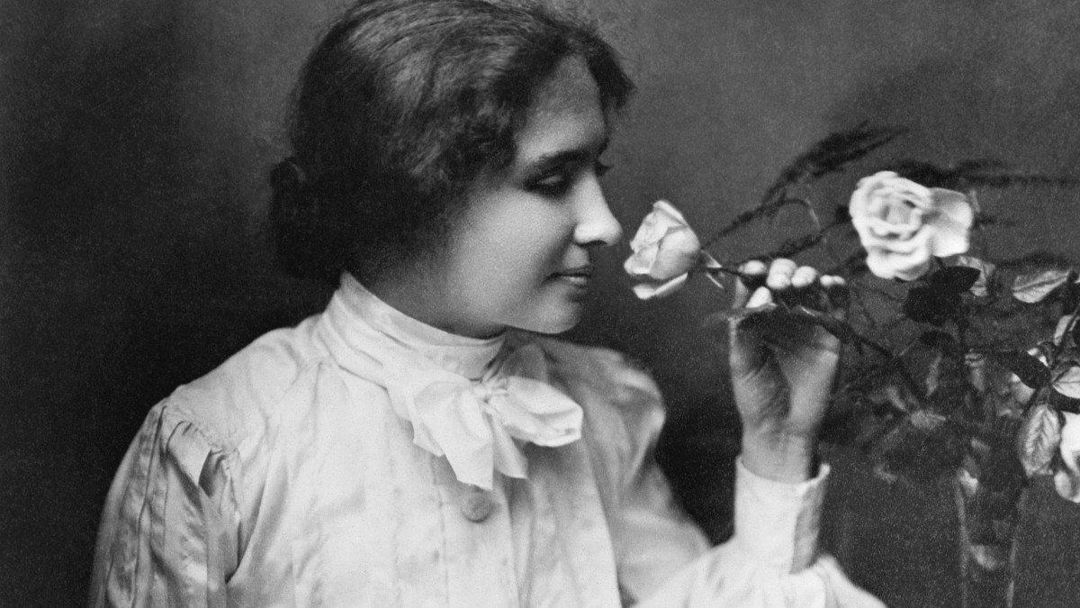
Helen Keller
Helen Keller was the first of two daughters born to Arthur and Katherine Keller on June 27, 1880 in Tuscumbia, Alabama. When she was 19 months old, Helen became ill with something called “brain fever”. This caused her to lose her hearing and her sight. As she grew older, she struggled to control her emotions. When she was angry, she would kick, scream, and try to hit people out of frustration. Helen’s worried parents took her to the Perkins Institute for the Blind in Boston, Massachusetts. There, she met with Anne Sullivan.

Anne Sullivan became her teacher and mentor for the next 49 years. At first, Helen didn’t make the connection between the sign language Anne was teaching her and the objects they represented. One day, Anne took Helen’s hand and ran it under the water pump. As she pumped water over one hand, she signed w-a-t-e-r in her other hand. Helen spelled w-a-t-e-r back on Anne’s hand. She finally understood that sign language was a way to communicate! By the end of the day, she had learned signs for more than 30 words.

Helen worked very hard to learn how to communicate with others. She learned touch-lip reading, Braille, speech, and finger-spelling. She attended college and began traveling around the world speaking about the welfare of the deaf and blind. She helped found a group that fought for basic human rights called the American Civil Liberties Union (ACLU). She spent her life trying to help those who struggled to help themselves.

Directions: Use text evidence to answer the following questions about Helen Keller. For each question, go back to the text and mark where you found your evidence!

- Why was life difficult for Helen Keller?
  - She went to a school in Boston.
  - She was unable to see or hear.
  - She formed the ACLU.

- Helen was famous for helping others. What piece of evidence supports this claim?
  - “One day, Anne took Helen’s hand and ran it under the water pump. As she pumped water over one hand, she signed w-a-t-e-r in her other hand. “
  - “As she grew older, she struggled to control her emotions. When she was angry, she would kick, scream, and try to hit people out of frustration.”
  - “She helped found a group that fought for basic human rights called the American Civil Liberties Union.”

Read the following sentence.

“She attended college and began traveling around the world speaking about the welfare of the deaf and blind.”

- According to the sentence, what does the word, welfare, mean?
a. Rights
b. Food
c. Movement
- Helen Keller is able to communicate by ____________________________________, ____________________, ___________________________, and ______________________________.

- How was Anne Sullivan influential to Helen Keller?
_________________________________________________________________________________________________________
_________________________________________________________________________________________________________
__________________________________________________________________________________________________________________________________________________________________________________________________________________
_________________________________________________________________________________________________________
_________________________________________________________________________________________________________

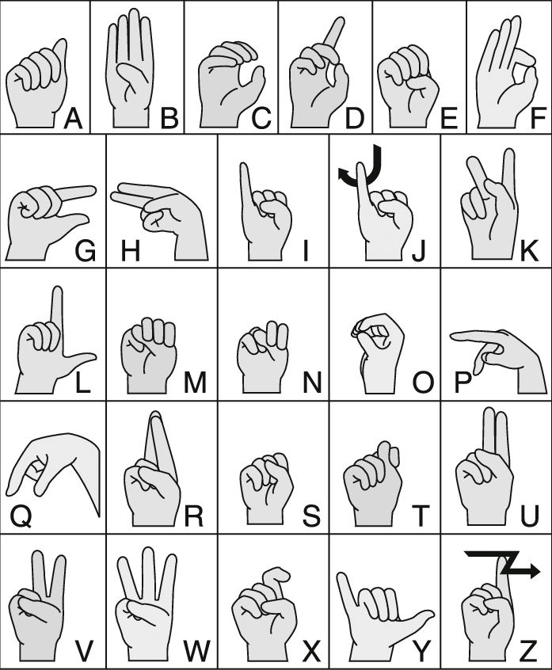
Use the chart to spell the following:

- Your name
- Your school
- Your teacher’s name
- Your city (Lawrence)
- Your state (Massachusetts)
- Your favorite color

to receive a formal education

