Grade 2 Work Packet
(week 3)

Paquete del Grado 2

Reading Log

Registro de Libros

Date/ Fecha | Title of Book Read/  Titulo de libro leido | Time Reading/ Tiempo Leyendo | Family Signature/ Firma de familia
3/30/20
3/31/20
4/1/20
4/2/20
4/3/20

Name: __________________________________________ Date: __________________________

Take Care of Our Planet

Keep Earth Clean. You can help solve the trash problem.
Our trash is piling up. Each American throws away an average of about 4½ pounds every day. That adds up to more than 1,600 pounds of trash per person every year!
The trash includes bottles, cans, boxes, paper, tires, and much more. Much of it ends up in landfills. Those are places where people dump trash.
April 22 is Earth Day. The day reminds people to take care of the earth. People can help by following the three Rs—reduce, reuse, and recycle.
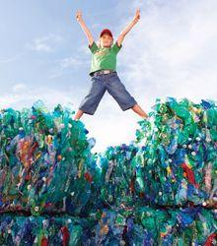
Britt Erianson/Getty Images
Many types of plastics can be recycled.
Reduce
You can reduce the amount of trash you throw away. Reduce means “to make less.” Here are some ways to make less trash:
FoodPix/Jupiter Images
- Use less paper by writing on both sides of each sheet.
- Instead of throwing out old toys or clothes, sell or donate them.
- If you buy something, don’t ask for a paper or plastic bag. Instead bring your own cloth bag.
Recycle
You can recycle. When something is recycled, it is made into something new. Here are some items that can be taken to a recycling center.
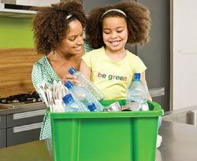
Image Source/Getty Images
- cardboard
- aluminum cans
- paper
- certain plastics
- glass bottles
- newspaper
Reuse
You can try to reuse things before you throw them in the trash. Reuse means “to use again.” Here are some examples:
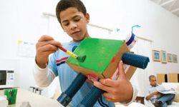
Alistair Berg/Getty Images
- Use an old T-shirt as a dust cloth.
- After opening a gift, save the wrapping paper and use it again.
- Make an art project using odds and ends such as string, bottle caps, and scraps of paper.
Copyright © 2009 Weekly Reader Corporation. All rights reserved. Used by permission.
Weekly Reader is a registered trademark of Weekly Reader Corporation.

Name: __________________________________________ Date: __________________________

Directions: Use text evidence to answer the following questions about the passage Take Care of Our Planet.
For each question, go back to the text and mark where you found your evidence!

- What is the problem described in this article?

  - People can help by reducing, reusing, and recycling.
  - Earth Day is April 22 each year.
  - Our trash is piling up and ending up in landfills.

- According to the article, which is an example of reusing?

  - Taking cardboard, cans, and newspaper to the recycling center
  - Writing on both sides of a piece of paper
  - Using an old T-shirt as a dust cloth

- A little girl stopped her mother from throwing away string, bottle caps, and paper because she wanted to use them. Based on the information in this article, what will the girl most likely want those items for?

  - To donate them
  - To make an art project
  - To sell them to a friend

- Use clues from the text. What does the word landfill mean?
  - A piece of land like an island
  - Places where people dump their trash
  - A center where you recycle materials

- What is this article mostly about?
  - The article is about how people each throw away more than 1,600 pounds of trash every year.
  - The article is about how to make art projects out of odds and ends.
  - The article is about the trash problem and three solutions to solve it.

- What do the three R’s stand for, and how do they help solve the trash problem?
_______________________________________________________________________________________________________________________________________________________________________________________________________________________________________________________________________________________________________________________________________________________________________________________________________________________________________________________________________________________________________________________________________________________________________________________________________________________________________________________________________________________________________________________________________________________________

